**TITLE: - A Android and an iOS application EasyPark**

**ABSTRACT**

EasyPark is a comprehensive technological solution designed to address the growing parking challenges in urban areas, particularly in Indian cities where the rise in vehicle numbers has outpaced the availability of parking spaces. Utilizing advanced technologies such as sensors, software, and real-time data analytics, SmartPark provides a platform for both city officials and drivers to optimize parking space usage. Through an intuitive mobile app, citizens can reserve parking spots in advance and make payments based on dynamic pricing, ensuring efficient utilization of parking resources. By analyzing demand patterns and adjusting prices accordingly, the system strikes a balance between encouraging appropriate usage and maximizing revenue for city administrations. This approach not only helps reduce traffic congestion and pollution caused by vehicles searching for parking but also ensures a sustainable source of income for the city.

Top of Form

Ms. Shanmukha Priya .K Dr Rama A

**TITLE: - A Android and an iOS application EasyPark**

**PREAMBLE TO THE DESCRIPTION**

**THE FIELD OF INVENTION**

The field of invention for EasyPark falls under intelligent transportation systems (ITS) and urban mobility management, with a focus on smart parking solutions. EasyPark integrates technologies like sensor networks, real-time data analytics, dynamic pricing models, and mobile applications to optimize parking space usage in congested urban areas. It also aligns with environmental sustainability, traffic management, and economic efficiency, helping reduce congestion, pollution, and underutilization of parking resources.

**BACKGROUND OF THE INVENTION**

The **EasyPark** invention addresses the growing parking challenges in urban areas, particularly in cities with rising vehicle numbers and limited parking space. As urbanization leads to traffic congestion, illegal parking, and environmental issues, traditional parking management systems have proven inefficient. EasyPark offers a solution by using **real-time data**, **sensor networks**, and **dynamic pricing** to optimize parking space utilization. Through a **mobile app**, users can easily find, reserve, and pay for parking, reducing congestion and pollution. The system helps city administrations balance parking supply and demand while generating sustainable revenue.

**SUMMARY OF THE INVENTION**

The EasyPark invention is a smart parking solution designed to tackle urban parking challenges by optimizing the use of limited parking spaces. It utilizes sensor networks, real-time data analytics, and dynamic pricing algorithms to provide drivers with up-to-date information on available parking spaces. The system also allows users to reserve and pay for parking through a mobile app, making the process seamless and convenient.

Ms. Shanmukha Priya .K Dr Rama A

**TITLE: A Android and an iOS application EasyPark**

**COMPLETE SPECIFICATION**

**Specifications**

**EasyPark** integrates key components to optimize urban parking management. It uses **sensor networks** to detect real-time parking spot availability and **data analytics** to monitor demand and adjust prices dynamically. Through a **mobile app**, users can easily search, reserve, and pay for parking, with a secure **payment gateway** supporting multiple payment methods. The system features **dynamic pricing** to balance revenue and space usage, while a **dashboard** provides city administrators insights into occupancy and revenue. EasyPark also includes **sustainability features**, reducing congestion and pollution, and is scalable for deployment across various locations. It ensures security and compliance with local regulations, offering a streamlined solution to urban parking challenges.

Ms. Shanmukha Priya .K Dr Rama A

**TITLE: - A Android and an iOS application EasyPark**

**DESCRIPTION**

Top of Form

EasyPark is a smart parking solution that uses sensors and data analytics to monitor real-time parking availability and optimize space usage. Through a mobile app, users can search, reserve, and pay for parking with ease, supported by dynamic pricing to balance demand and revenue. The system reduces congestion and pollution by guiding drivers to available spots. City administrators benefit from a dashboard offering insights on occupancy and revenue. EasyPark is scalable, secure, and ensures compliance with local regulations, making it an efficient solution for urban parking management.

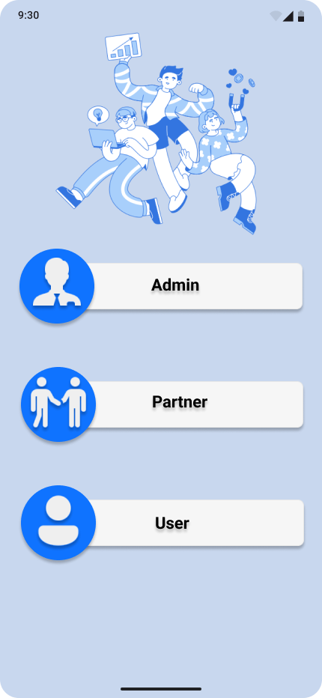

Figure 1 Home page of EasyPark

Ms. Shanmukha Priya .K Dr Rama A

**TITLE: - A Android and an iOS application EasyPark**

CLAIM

**We Claim**

EasyPark implements multi-level access control, allowing City Administrators, Parking Operators, Users, and Guests simultaneous access while restricting functionalities based on user roles. This enhances security and efficiency by ensuring that each user can only access features relevant to their role within the system.

**Claim: Dynamic Pricing Optimization**  
EasyPark simplifies parking management by automating the adjustment of parking rates based on real-time demand. This reduces administrative workload and ensures optimal pricing strategies that balance revenue and parking space utilization, improving the overall effectiveness of parking management.

**Claim: Real-Time Parking Analytics**  
Utilizes data analytics tools to monitor parking space usage and demand trends within EasyPark. By leveraging real-time data and predictive analytics, administrators can identify usage patterns, optimize space allocation, and improve overall parking efficiency.

**Claim: User Feedback Integration**  
Facilitates continuous improvement of the parking system by incorporating user feedback within EasyPark. This empowers administrators to gather insights, address concerns, and make enhancements based on user experiences, ultimately improving the quality of the parking solution and user satisfaction.

Ms. Shanmukha Priya .K Dr Rama A